Patient’s Name:
D.O.B: |  |  |  |  | NHS No:
Address:
GP:
Practice:
Allergies / Sensitivities:
Special Instructions: Document any analgesic patch (type, strength & location).
Latest eGFR: |  | Date:

*Adjustments within dose ranges should be justified by symptoms and any previous medicines administered. Please record these in the Electronic Clinical Record.
NB. ONLY PRESCRIBE AND ADMINISTER THOSE MEDICATIONS CLINICALLY INDICATED
Delete medicines discontinued with a single line, signature & date

Date author-ised | Name, Form & Strength of Drug |  | PRN Dose  or Range * | Route | Minimal Interval | Seek advice before exceeding | PRINT name against each prescribed drug
 | MORPHINE SULFATE INJ.  10mg / ml | Opioid naïve? | 1.25-2.5mg | SC | 1 hour | If titrating  6 doses in 24hrs
 | Pain, breathlessness, cough |  |  | SC | 1 hour | If on driver or patch  4 doses in 24hrs
 | HALOPERIDOL INJ. 5mg / ml  Nausea, vomiting, delirium |  | 0.5-1.5mg | SC | 4hrs | 4 doses in 24hrs
 | HYOSCINE BUTYLBROMIDE INJ. [Buscopan® ] 20mg / ml  Distressing oral or chest secretions or abdominal colic |  | 20mg | SC | 4hrs | 4 doses in 24hrs
 | MIDAZOLAM INJ. 10mg / 2 mls  Anxiety, agitation, breathlessness |  | 2.5-5mg | SC | 1 hour | 4 doses in 24hrs
 | WATER FOR INJECTION  To flush line |  | 0.5ml | SC | None

For Specialist Palliative Care Advice Out of Hours contact the team covering the patient’s GP practice
Countess of Brecknock, Andover 01264 835288 | Oakhaven Hospice, Lymington 01590 670346
Mountbatten Hospice, Southampton 02380 475528 | Rowans Hospice, Portsmouth 02392 250001
St Michael’s Hospice, Basingstoke 01256 844744 | Salisbury Hospice 01722 425113
The Beacon Centre (9am-5pm) 07867 780538  Phyllis Tuckwell Hospice (24 hour) 01252 729400 | Macmillan Unit, Christchurch Hospital 01202 705470  (Out of hours 01202 705291)
St Wilfrid’s Hospice, Chichester 01243 775302 | Midhurst SPC Team (8.30am – 8.30pm) 01730 811121

General Practice: Complete on screen, then ‘send as attachment’ from within EMIS/S1 via the prescriber’s NHSmail account directly to your community team’s generic NHSmail address.
Alternatively, if still printing, signing by hand, scanning and sending this document via a practice generic NHSmail account, then please also sign against each prescribed drug.
This form has been generated in EMIS by Dr INSERT NAME while logged on with their smartcard.
Received from Prescribers/Practice NHSmail. Recipient: ….……….……..…..….… Sign: ……..……..………. Date: …..….…

Golden Rules
- Assess and diagnose the cause of symptoms before planning symptom management.
- Treat potentially reversible causes, where appropriate e.g. constipation, retention or dressing a pressure ulcer.
- Always consider non-drug approaches e.g. positioning, a calm environment, information for patient, carers &/or family. They are as important as the use of drugs.

Recording
- Record drug, dose given and “reason for use” in the electronic clinical record.
- Record a description of where, when, how bad and your reasoning, particularly for patients unable to communicate §. Writing solely “pain” or “agitation” is poor record keeping and is not clinically helpful.

General Points
- Generally injections do not work any better than oral medication. Cases where oral medications are not absorbed are rare, though this may happen towards the end of life alongside swallowing becoming more difficult.
- Appropriate opioid use at the end of life does not shorten life, but uncontrolled pain can. Rarely, dying patients may experience distress when symptoms cannot be controlled, despite expert palliative care advice / involvement. In these rare circumstances, some patients may require sedating medication to diminish awareness of their discomfort.
- Medicines with a sedating effect: monitor the dose to ensure that it is the minimum required to relieve distress. Medication used in this way does not shorten life.

Pain assessment in cognitive impairment §
- Patients may be slower to express pain, less able to localise it, or express it differently (e.g. aggression towards themselves or others). If so, use an observational scale such as the PAINAD (particularly for patients with dementia) which can be found here.
- For further advice speak to a local end of life dementia CNS or Learning Disability team.
Opioid Conversion Chart Wessex Palliative Physicians Handbook of Palliative Care 9th edition 2019
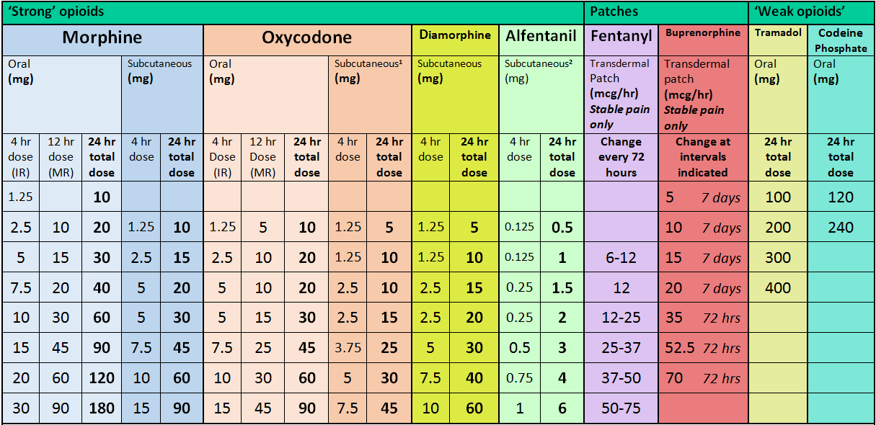
¹Some units recommend a 1:1 conversion from CSCI morphine to CSCI oxycodone rather than the 2:1 conversion in the table above
²Some units recommend an 18:1 conversion from PO morphine to CSCI alfentanil rather than the 30:1 conversion above
*Seek specialist advice when doses are greater than the equivalent of 120- 200mg of oral morphine in 24hours.

Exceptions to Normal Anticipatory Meds
- Renal Failure: if eGFR is below 30 drug accumulation, particularly of morphine, may lead to increased side effects. Please seek advice as necessary.
- If previously taking oral oxycodone use SC oxycodone (10mg/1ml at ½ oral dose) where possible.
- The same applies for Levetiracetam (100mg/ml at same dose). Where this is not available, and for replacement of other oral anticonvulsants, CSCI midazolam should be considered.
- Patients with intra-cranial pathology (brain mets, CVA, dementia) appear more sensitive to Haloperidol CNS side effects, in these cases lower doses or use alternative medications e.g. cyclizine, metoclopramide or levomepromazine depending upon the cause of nausea
- Anti-psychotics are best avoided in patients with Parkinson’s disease or PSP. Use cyclizine 1st line for N&V in these patients.

