1 – Importing Future Planning Resources into SystmONE

**1.** The following process requires a staff member with S1 Administrator Rights

**2.** Go to [www.futureplanning.org.uk](http://www.futureplanning.org.uk) & follow instructions on the “Downloads for S1” page.

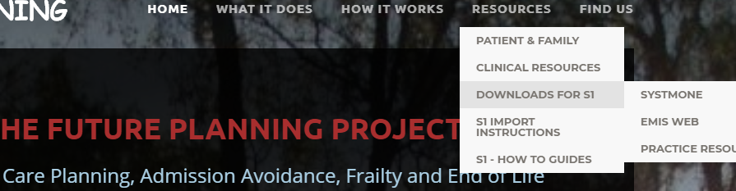

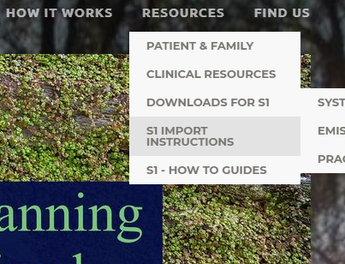

**7.** You are now ready to move to

sheet, “**2 – Adding FP Quick Links to S1**”

**6.** Ideally, import the resources

above into new folders entitled,

“Future Planning” in each area of S1.

**5.** Now follow the “S1 import instructions”.

**4.** You will also need to download and import the SHFT/Solent S1 Community Syringe Driver and PRN Admin Order charts. These can be found near the bottom of the webpage at;

[www.futureplanning.org.uk/csci-and-prn-downloads.html](http://www.futureplanning.org.uk/csci-and-prn-downloads.html)

**3.** You will need to save the following files to your local drive, prior to importing these into S1 in the order shown;

*a. Future Planning View b. Three Anticipatory Medication Views*

*c. Future Care Plan Word Document d. Future Planning Template*

*e. Anticipatory Medications Template f. FP Quick Links Template*