Future Planning Project – January 2018

Background
The Coordinating Future Care Register (South Hampshire) and Gold Register (North Hampshire) no longer exist. Both were rolled out to provide an electronic Palliative Care Co-ordination System (ePaCCS) across Hampshire. Neither was well used over their 2-3 year lifespans. Each required users to login, re-enter clinical data, already recorded elsewhere, and relied upon acute services accessing the registers to see if information was available for a particular patient; which was generally blank!

Outline
This project has developed identical templates with 4 short sections for the two main Hampshire GP clinical IT systems (SystmONE and EMISWeb). The templates support: Gold Standard Framework meetings; recording of a patient’s Future Care Planning or End of Life choices and Avoiding Unplanned Admissions (AUA) information. With patient consent, coded information and attached freetext will automatically transfer to a patient’s National Summary Care Record (SCR) where it can then be accessed by acute care services as required. Templates were rolled out via the LMC to Hampshire November 2016 and to East Berkshire practices, as part of a £300k LCS, April 2017.
The template, instructions for use and other supporting materials are all available free for general practices.
The template;
- is fully coded (CTV3, READ2 & by April 2018 SNOMED CT) supporting automatic data extraction of new or updated data to the SCR, with patient consent.
- coded data also uploads to the Hampshire Health Record or Berkshire C. Which allows extensive data & activity reporting across Hampshire.
- removes the need to re-enter clinic data to achieve ePaCCS requirements.
- supports production of a GSF Register report, showing all practice GSF patients, which services they are receiving and their prognostic stage. See Fig 1.
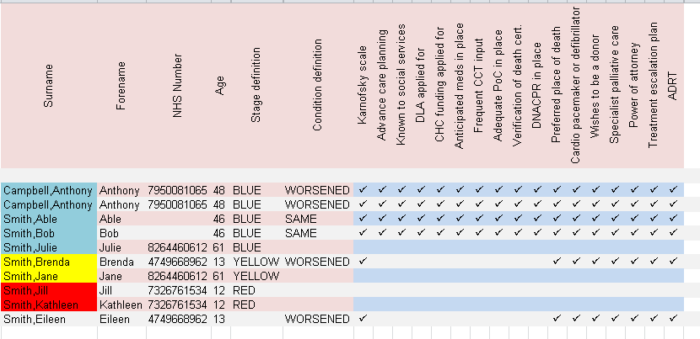
As we will be losing MiQuest in 2018-19 with the arrival of SNOMED CT, practice reports are being developed that will run within EMIS and S1.
- supports production of printed Future Care Plans, if a patient wants this.
- removes the need to fax or NHSmail details of poorly patients to ambulance, hospice, community and OOH services.
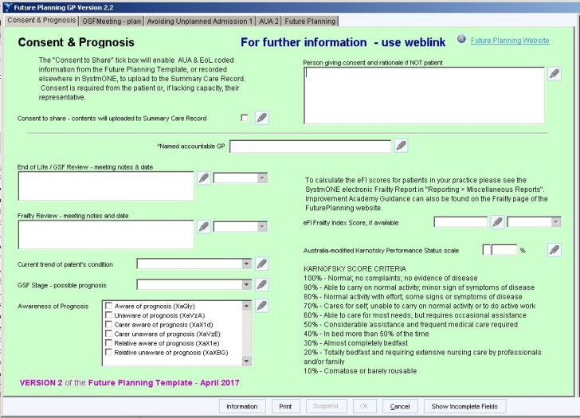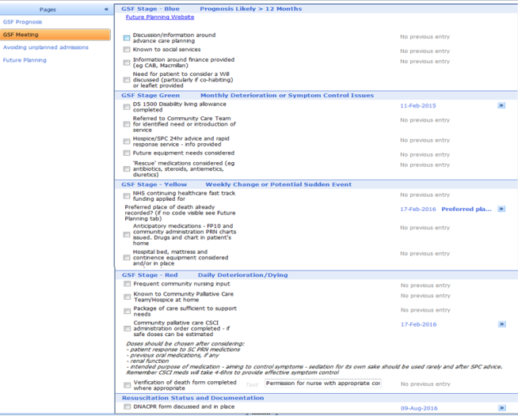
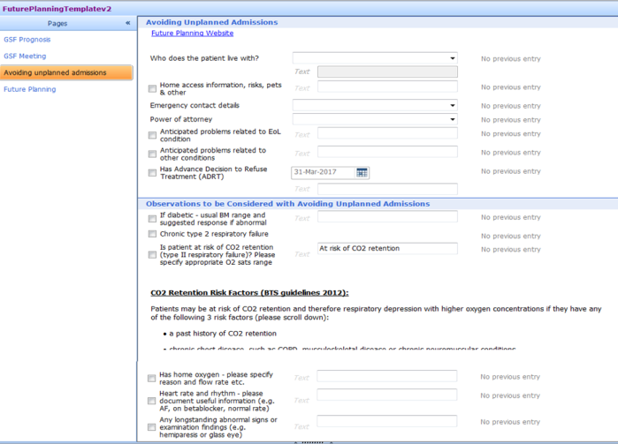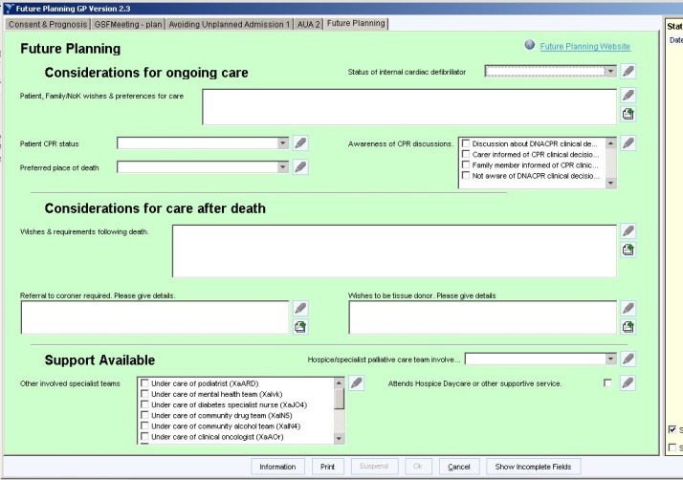

Past Milestones
NHS England Harnessing Technology funding (£63k awarded) | April 2017
Future Planning Version 2 released. Including frailty codes to support the new July 2017 GP contract | May 2017
All Hampshire OOH GP services able to access Summary Care Record (SCR) | Summer 2017
Future Planning Administrator in post. | October 2017
FP Project presented via NHS England Harnessing Technology WeBeX | 1pm, 8th Nov 2017
Draft Future Planning: My Wishes leaflet sent to 1200 hospice volunteers for feedback | November 2017
New Project Data reports produced by the CHIE Analytics team. Will allow the same reports to be developed in Berkshire once GPs are connected to Care Centric. | December 2017
South Coast Ambulance Service EoL FAQs completed and ready to go, once smartcard issues resolved, alongside SCR FAQs and My Wishes leaflet. | January 2018
Printing of the Future Planning: My Wishes leaflet. A self complete form that encourages recording of preferences for care and SCR consent, that is then handed to the GP practice for addition to a patients’ record. | January 2018

Future Milestones
Rollout EoL and SCR FAQs to South Coast Ambulance Service. Staff told to access SCR for all 999 and many 111calls. Part of their response to their CQC report focus on EoL care provision. | February 2018
FP Project presented again via NHS England Harnessing Technology WeBeX | 1pm, 14th March 2018
Future Planning /AgeUK/NHS Digital Workshop | 5th February 2018
Release of the Future Planning: My Wishes Leaflet
Develop common agreed uDNACPR coding set and set NHS Digital to develop APIs to allow better sharing of this data across systems
Future Planning template version 3 released. Includes “Treatment Escalation Planning” enabling recording of information for Acute Trusts using ReSPECT paper form. Includes eDNACPR tab. | April 2018
SHFT start showing RiO information in CHIE that builds on Future Planning information coming from each GP practice.
Solent rollout of Community Future Planning template begins
Reach Hampshire 10000 patients consenting for Additional Information upload to the SCR via use of the Future Planning template. Number likely to be much higher in East Berkshire. | Spring 2018
Project Data reports have GP anonymization removed as each CCG approves. | Spring 2018
Increased number of CCGs utilising Future Planning and My Wishes. Sustainable funding model developing. | Spring 2018
EMISweb and SystmONE practice reports allowing EoL & Frailty registers to be produced without the need for MiQuest | Mid 2018
Change Future Planning Template over to SNOMED CT coding including an eDNACPR TAB | Mid 2018

Team
Future Planning administrator post.
Members of the Wessex Data and electronic Palliative Care Co-ordination (ePaCCS) Subgroup (linking to SHFT End of Life Steering Group and the Wessex Palliative Care and EoL Network Group). Chaired by Dr Steve Plenderleith, Consultant in Palliative Medicine, with clinical representation from all Hampshire Hospices, SHFT, Solent NHS Trust and the three acute trusts, working alongside the Clinical Support Unit and CCG commissioning staff. Five End of Life CCG GP leads also attend.

For further information please go to:

www.futureplanning.org.uk

