2 - How to add Future Planning

Quick Links to the S1 Patient Tree

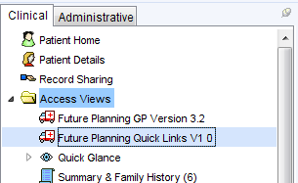

1. Requires a staff member with S1 Administrator Rights

**2.** Go to Setup >Users & Policy >Organisation Preferences …

Clinical Policy >Tree Configuration

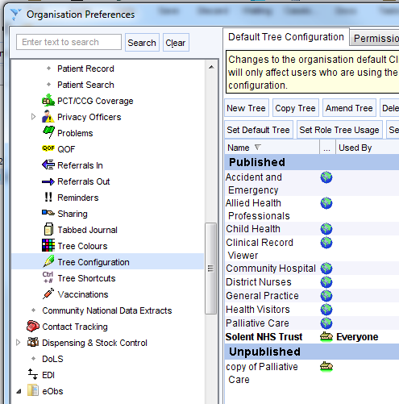

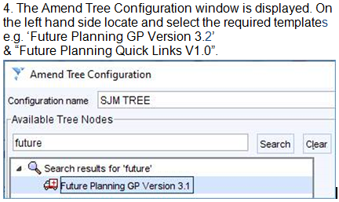

**5.** Then add each to the selected tree nodes list on the right hand side in the required position within the list.

Click OK twice to close windows and save the new settings.

**3.** Select the relevant tree name, possibly; “**Practice Name – Everyone**”