2 - How to add Future Planning

Quick Links to the S1 Patient Tree

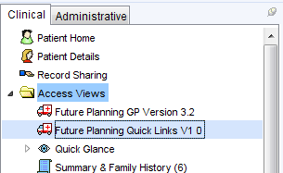

1. Again this requires a staff member with S1 Administrator Rights

**2.** Go to Setup >Users & Policy >Organisation Preferences …

Clinical Policy >Tree Configuration

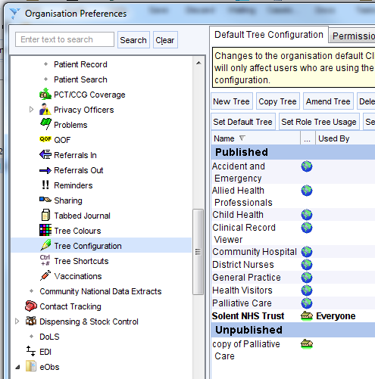

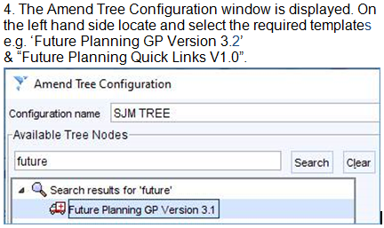

**5.** Then add each to the selected tree nodes list on the right hand side in the required position within the list.

Click OK twice to close windows and save the new settings. Ideally placing the two Future

Planning items immediately

adjacent to the Summary Care Record

link or in the Access Views folder if prominent.

**3.** Select the relevant tree name, possibly; “**Practice Name – Everyone**”